Enhancing Students’ Voices in a Voiceless IoT Ecosystem
Source: https://doi.org/10.1007/978-3-030-85720-2_2.
Lorenzo M.N., Lovtskaya A. (2021) Enhancing Students’ Voices in a Voiceless IoT Ecosystem. In: Daniela L. (eds) The Internet of Things for Education. Springer, Cham. pp. 7-28.
“In a wired world of wireless connection, IoT creates environments for machine–machine interaction and human–machine interdependency.
This chapter provides educational reflections and examples for applying transmedia approaches and collaborative methodologies in complex IoT ecosystems. The authors identify physical and intangible components in IoT communicative networks, for individual learning and collective ethical decision-making. They debate the role of transmedia interaction and connectivity for facilitating students’ learning autonomy, and for empowering social participation. They also analyze school projects oriented to solving common global problems related to the Sustainable Development Goals from the UN Agenda 2030, and finally provide a case study of personalized learning in a hyperconnected environment. The study's result provides a synthesis of the benefits of several approaches, which are useful for learning on the Internet of objects, people, and interests that engulf the whole planet.”
Examples from Catalan Schools:
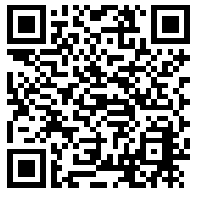  Use this QR code to access this and other similar Magnet Schools’ projects in Catalonia. | The Institut Nicolau Copèrnic in Terrassa — an industrial town in Catalonia not far from Barcelona — is an example of a secondary school that is trying to enhance students' interest in scientific culture and technology. By experimenting with robotics, smart devices, and IoT sensors they explore inclusive learning ecosystems, where the students are empowered with decision making and leadership roles (Carbonell, 2019, p. 8-11).  [https://www.fbofill.cat/sites/default/files/Magnet-revista-2019.pdf]

here]
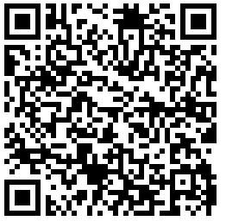  Use this QR code to access a video about the project. | For over five years now, the school Escola Rel, for kids with special needs in Terrasa has been using smart connected devices to set up and care for the school vegetable garden, in their project SMART – HORT Taula de cultiu intel·ligent (Ramos, 2014). Using Scratch, students can install sensors to detect soil irrigation needs, build a watering system for a vegetable garden, and manage all this project information through their telephones. They analyse the whole process in class, and explore connectivity benefits and consequences.  [https://www.youtube.com/watch?v=21riqj75Fwo&feature=youtu.be]
_____________________
For more information, contact: @NewsNeus <nlorenzotec.cat>

