**ACTIVITY 1**   
LEARNING TO THINK AND SHARE: Who is helping?

1. **Observation**: Look carefully at this Picture:



1. **Description**: What do you see in this picture? Describe the general scene and focus on details too.
2. **Narration**: What do you think happened? Explain the most likely timeline for this situation.
3. **Argumentation**: How can you sustain your story? Look for evidence and share your explanations. Organize a debate, reasoning with your colleagues or classmates.

**To know more:**  
BBC: https://233livenews.wordpress.com/2015/03/19/incredible-photos-see-how-india-students-pass-apor-during-exams/

**Assessment suggestion:**

1. Describe, in your own words, what you have learned and what strategies you have used during this activity.
2. Reflect and explain the different text formats (typologies) you have used for this activity.
3. Share personal feelings and ethical considerations.

**ACTIVITY 2**   
LEARNING TO THINK AND SHARE: Who ate my bicycle?

1. **Observation**: Look carefully at this Picture (GettyImage)



1. **Description**: What do you see in this picture? Describe the general scene and focus on details too.
2. **Narration**: What do you think happened? Explain the most likely timeline for this situation.
3. **Argumentation**: How can you sustain your story? Look for evidence and share your explanations. Organize a debate, reasoning with your colleagues or classmates.

**To know more:**  
IGetSIDE: https://www.gentside.com/insolite/ce-velo-est-incruste-dans-cet-arbre-depuis-pres-de-60-ans_art47450.html

**Assessment suggestion:**

1. Describe, in your own words, what you have learned and what strategies you have used during this activity.
2. Reflect and explain the different text formats (typologies) you have used for this activity.
3. Share personal feelings and ethical considerations.

**ACTIVITY 3**   
LEARNING TO THINK AND SHARE: Is it Fake or Real?

1. **Observation**: Look carefully at this Picture (Wikipedia).

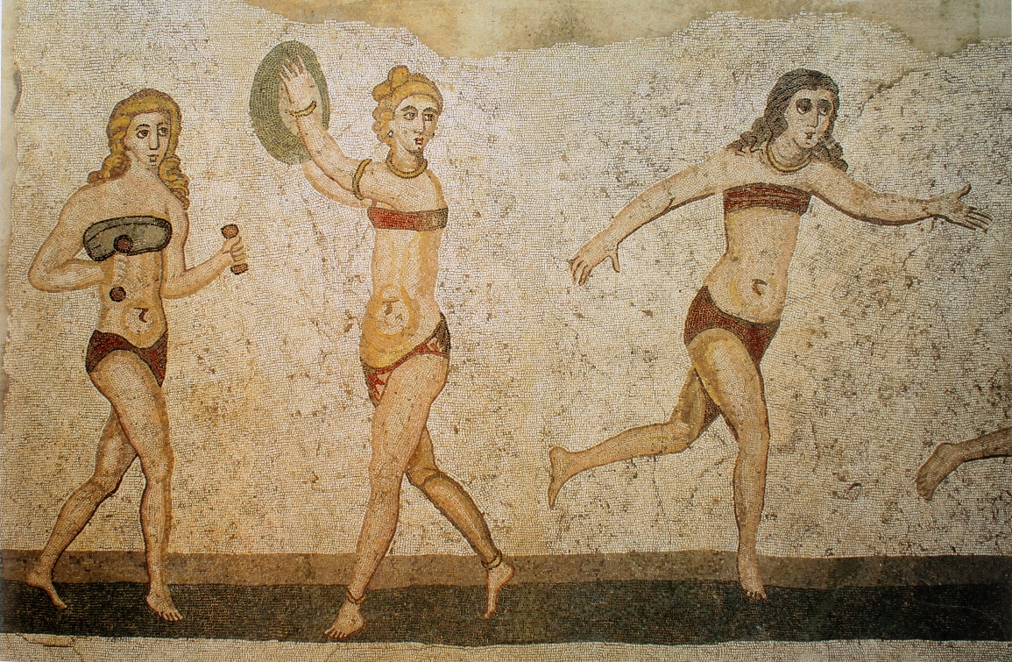

1. **Description**: What do you see in this picture? Describe the general scene and focus on details too.
2. **Narration**: What do you think of this picture? Explain the most likely origin of this image.
3. **Argumentation**: How can you sustain your opinion? Look for evidence and share your ideas. Organize a debate, reasoning with your colleagues or classmates.

**To know more:**  
*Wikipedia*: <https://en.wikipedia.org/wiki/Villa_Romana_del_Casale>  
<https://en.wikipedia.org/wiki/Villa_Romana_del_Casale#/media/File:Mosa%C3%AFque_des_bikinis,_Piazza_Armerina.jpg>

**Assessment suggestion:**

1. Describe, in your own words, what you have learned and what strategies you have used during this activity.
2. Reflect and explain the different text formats (typologies) you have used for this activity.
3. Share personal feelings and ethical considerations.